unj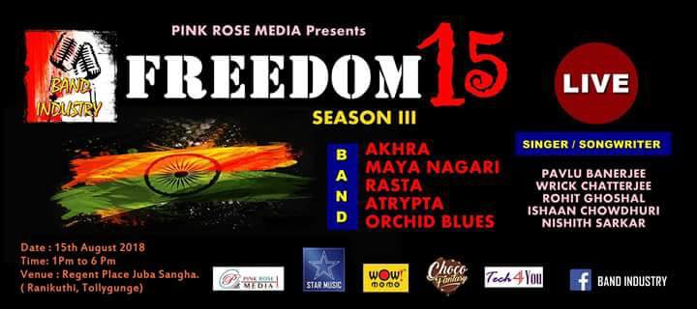

On this 72nd day of independence on 15th August 2018, like the previous year’s Pink Rose Media in association with Band Industry is celebrating this auspicious day of with a band program namely ***FREEDOM_1, SEASON_III*** at Regent Place Juba Sangha, Tollygunj. The participating bands are Akhra, Maya Nagari, Rasta, Atrypta and Orchid Blues. There will be other solo performances all going live from 1 pm onwards on the said day.

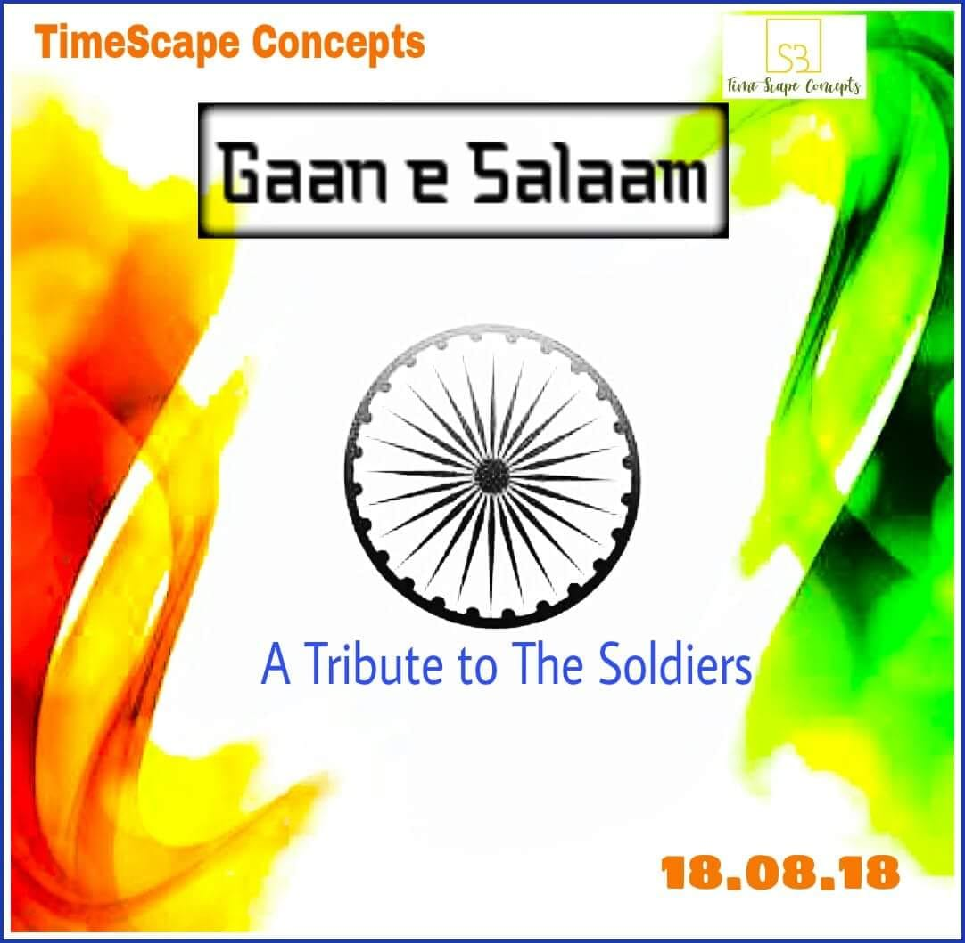

A tribute to the valiant lost lives for our countries freedom, TimeScape Concepts is presenting a musical evening at Dr Triguna Sen Auditorium, Jadavpur on 18th August 2018. Many participating bands will be participating on this event to donate a day in respect to all the soldiers who are the main cause to usher freedom to our nation.